**ASP Web API Get Method-XML data format**

Create an Api controller called MoviesController. Add a Get method with no parameters which will return the List of movie details.

Create a Model class in models folder as Movie.

Create a static list of movies as given in the screenshot. Display those movie details using the get method.

Movies List:

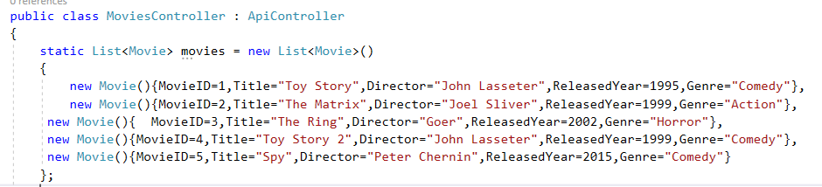

Get method return type should be List<Movie> which should be displayed as sorted by movie title.

**Sample Output:**

**The Url in browser will be** <http://localhost:63584/api/Movies>

